*Florida International University*

*School of Computing and Information Sciences*

Software Engineering Focus

Interactive Paint

User Story ID <1>

**Name:**

Daniel Mederos

**Team Member(s):**

Jim Louro

**Project:**

Interactive Paint

**Product Owner(s)**:

Francisco Ortega

**Mentor(s)**:

**Instructor**: Masoud Sadjadi

**User Story Name:** Create UNDO

* Description: As a User I would like to create an UNDO so that it can fill an area in the GUI Canvas

Acceptance Criteria

* The undo should be able to undo an action on the Canvas
* The dropdown menu with the edit button should be presented to the user
* The undo button in the dropdown menu when clicked should undo an action on the canvas

**Use Case** Create an UNDO action in the Canvas

|  |  |  |
| --- | --- | --- |
| #**344** Implement UNDO | | |
| ***Description*** | When the user clicks on the undo button, the user should then be able to undo the previous action that was made by the user on the canvas | |
| ***Actor*** | User of Interactive Paint | |
| ***Precondition*** | GUI must be running | |
| ***Flow of Events*** | **User** | **System** |
| **1.** | User starts Paint Program | The paint program loads the GUI Canvas |
| **2.** | User clicks on edit button | A dropdown menu appears and the edit button appears |
| **3.** | User clicks on undo button | The canvas will return to its previous state before the last action before the undo button was clicked on |

**Use Case Diagram**

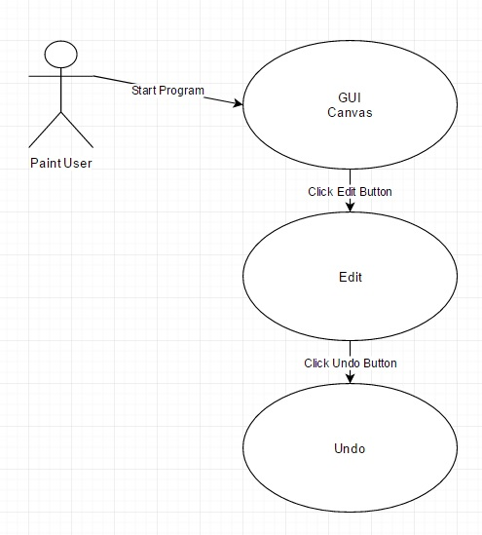**Sequence Diagram**

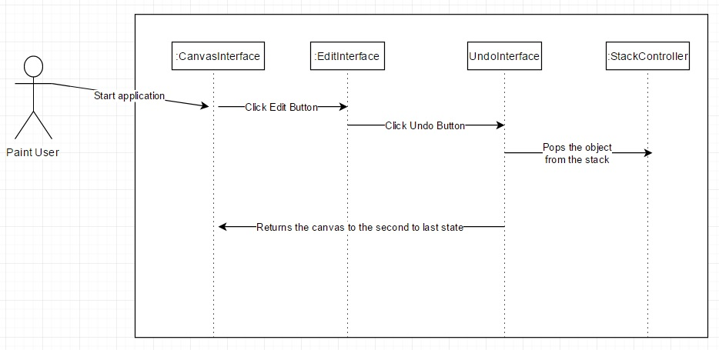

**Class Diagram**

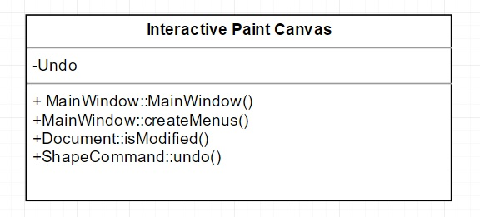

**Integration Test**

**Testing**

**Description:**

* Test the undo button and returns the canvas to the previous state

**Work Log:**

**Unit Test**

**Test Case 1 (sunny)**

***Purpose:*** to test that the undo button appears when user clicks on undo button

* Precondition The user must have QT plugin for visual studio and must run the program
* Input: User clicks on undo button which then a drop down menu appears
* Expected Result: undo button appears on GUI Canvas from a drop down menu
* Actual Result: Actual result was found to be the expected result.
* Status: **PASSED**

**Test Case 2 (sunny)**

***Purpose:*** to test that the undo button properly lets the user return the canvas to the previous state

* Precondition The user must have QT plugin for visual studio and must run the program
* Input: User clicks on undo button which then a drop down menu appears and must click undo
* Expected Result: returns the canvas to the previous state
* Actual Result: Actual result was found to be the expected result.
* Status: **PASSED**



